**JS Script Hint**

* **Semicolon** – don’t need after statement unless few comments in a single line
* **Comment** - // single line, /* … */ mulit-lines
* **Variables –** letters, numbers, $, and _
  + Case sensitive
  + String – single quotation or double quotation marks
  + Numeric –
* **Operators**
  + **comparision**
    - **===** equal and same type
    - **!==** not equal and not a same type
* **String Concatenation**
  + Use “+” plus sign to connect two strings
* **Escape Character**
  + Use “\” backslash to ignore the special character
* **Function**
  + Function name is case sensitive
  + Best Practice – the first letter use lower case, then the rest of words captialise
* **Variables scope**
  + local - “var” inside function
  + global – outside of function or don’t use “var” inside function
* **Typeof**
  + use for checking the type of variables
* **Document Object Model (DOM)**
  + Object – consists of properties (attributes) and methods
* **DOM object hierarchy**

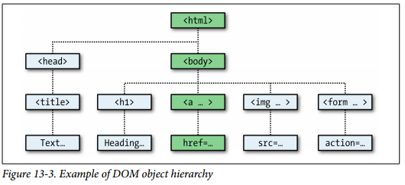

* **document.write()** 
  + sfd
* HTML DOM Object
  + document.getElementById(id) – Find an element by element ID
  + document.getElementByTagName(name) – Find an elements by tag name
  + document.getElementByClassName(name) – Find an elements by class name